
Project - High Level Design
on
Manufacturing Flask App

Course Name: DevOps Foundation

Institution Name: Medicaps University – Datagami Skill Based Course

Student Name(s) & Enrolment Number(s):

Sr no | Student Name | Enrolment Number
01 | Vidhi Prajapati | EN22CS3011076
02 | Tanishka Raghuwanshi | EN22CS3011019
03 | Soumya Shrivastava | EN22CS301978
04 | Srashti Sen | EN22CS301983
05 | Tarun Patidar | EN22CS3011034

Group Name: Group 12 DS Project Number: DO-12
Industry Mentor Name: Mr. Vaibhav University Mentor Name: Dr. Ritesh Joshi
Academic Year: 2022-202c

Table of Contents

- Introduction.
  - Scope of the document.


1.3. System overview.
- System Design.
  - Application Design
  - Process Flow.

  - Information Flow.
1.2. Intended Audience

  - Components Design
  - Key Design Considerations
  - API Catalogue.
- Data Design.
  - Data Model
  - Data Access Mechanism
  - Data Retention Policies
  - Data Migration
- Interfaces
- State and Session Management
- Caching
- Non-Functional Requirements
  - Security Aspects
  - Performance Aspects
- References

Introduction
This document presents the High-Level Design (HLD) of the Manufacturing Order C Inventory Management System. The system is developed using Python Flask as the backend framework and React as the frontend user interface. It provides functionality for managing manufacturing orders, monitoring inventory levels, generating dashboard summaries, and performing system health checks.
The application follows a structured 3-tier architecture consisting of presentation, application, and data layers. RESTful APIs are used for communication between frontend



and backend, while SQLAlchemy ORM handles interaction with the SQLite database.
The purpose of this document is to describe the overall architecture, system modules, data design, process flow, and technical considerations involved in the development of the system.

Scope of the Document
This High-Level Design document covers:
    - Overall system architecture and design
    - Functional modules (Order Management, Inventory Management, Dashboard, Health Monitoring)
    - Data flow and process interactions
    - Database design
    - Containerization using Docker
    - Security and performance considerations
This document does not include low-level code implementation details, testing scripts, or deployment scripts. It focuses only on architectural and design-level representation of the system.

Intended Audience
This document is intended for:
    - Project evaluators and academic reviewers
    - Software developers and backend engineers
    - System architects
    - DevOps engineers
    - QA Team
It provides a structured understanding of how the system is designed, how components interact, and how data flows through different layers of the application.

System Overview
The system is a cloud-ready containerized web application designed to manage manufacturing operations such as inventory and order tracking using Flask, Docker, and Kubernetes.

- Users access the application through a web browser interface.



  - The user sends HTTP requests (Create Order, Update Inventory, View Records).
- The request is routed through a Kubernetes Service.

- Kubernetes Service forwards the request to one of the running Flask application Pods.

- The Flask application processes the business logic.

- SQLAlchemy ORM is used to interact with the database.

- The application communicates with the SQLite database to fetch, store, or update manufacturing data.
- The entire application is containerized using Docker.

- Docker ensures consistent environment across development and deployment.

- Kubernetes manages container orchestration, scaling, and rolling updates.

- Rolling Update strategy ensures zero downtime during new version deployment.

- The application can run inside Minikube (local cluster) or AWS EC2 (cloud deployment).

- If deployed on EC2, AWS provides scalable and reliable cloud infrastructure.

- The system supports stateless architecture, allowing horizontal scaling of Pods.

The system provides a scalable, containerized, and highly available manufacturing management solution using modern DevOps practices.

System Design
The Manufacturing Order C Inventory Management System follows a structured 3-tier client-server architecture to ensure modularity, scalability, and maintainability.
The system is divided into:
- Presentation Layer (React Frontend)
- Application Layer (Flask Backend APIs)
- Data Layer (SQLite Database via SQLAlchemy ORM)
This separation of concerns ensures that UI, business logic, and data storage remain



independent, making the system easier to
maintain and extend.
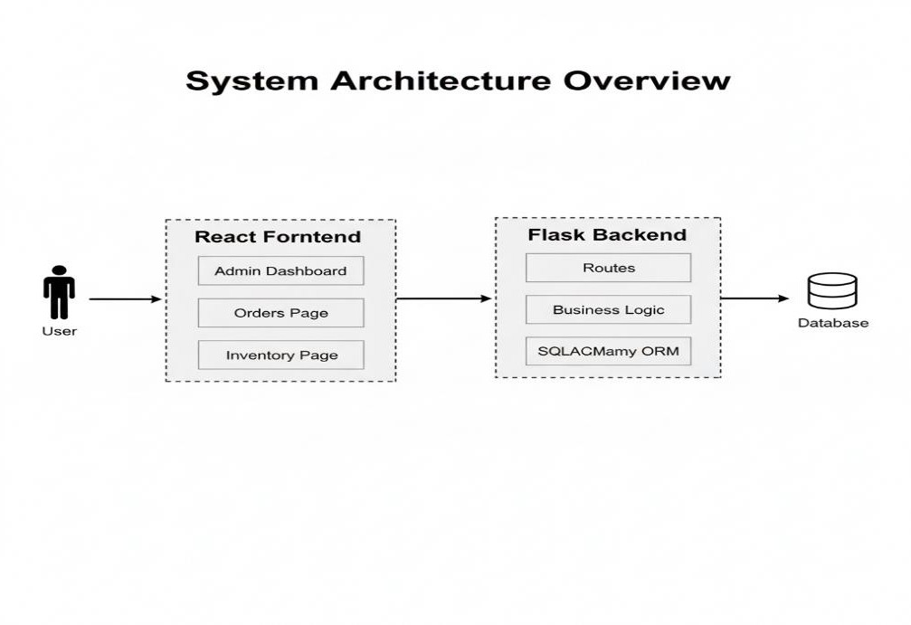

Application Design
The application is modular in structure.

Backend Structure
    - app.py → Application entry point
    - routes.py → API endpoint definitions
    - models.py → Database schema
    - config.py → Environment configuration
    - seed.py → Initial database setup
The backend follows RESTful principles and handles:
    - Order management logic
    - Inventory validation
    - Dashboard summary calculations
    - Health C readiness checks

Frontend Structure
    - AdminDashboard
    - OrdersPage


    - InventoryPage
    - UserDashboard
    - Reusable Components (Navbar, InfoCard, Badge, LoadingText)

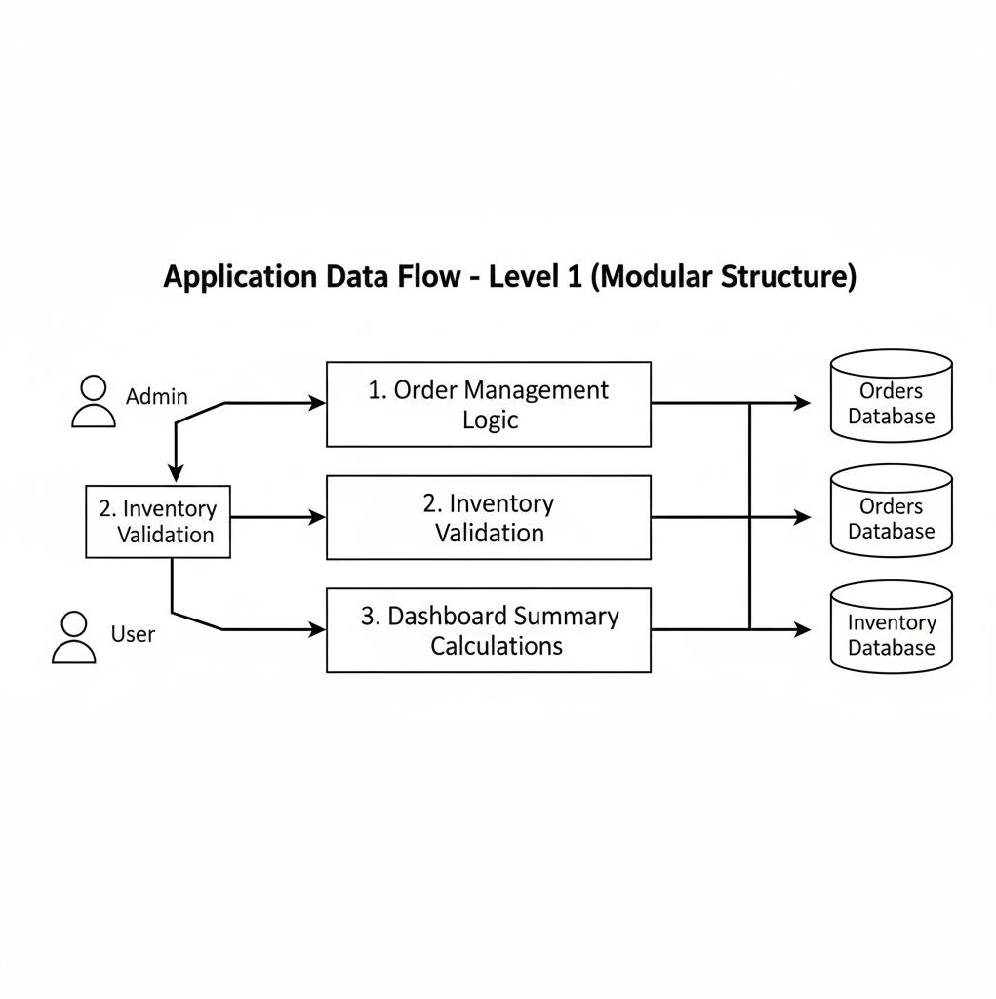

Process Flow

The system follows a structured request-response lifecycle.

Step-by-Step Process:
- User performs an action (Create Order / Update Inventory)
- React captures event
- Axios sends HTTP request to backend
- Flask route handler validates request
- Business logic executes
- SQLAlchemy queries SQLite database
- Database returns result
- Flask converts result to JSON


- React updates state
- UI re-renders with updated data
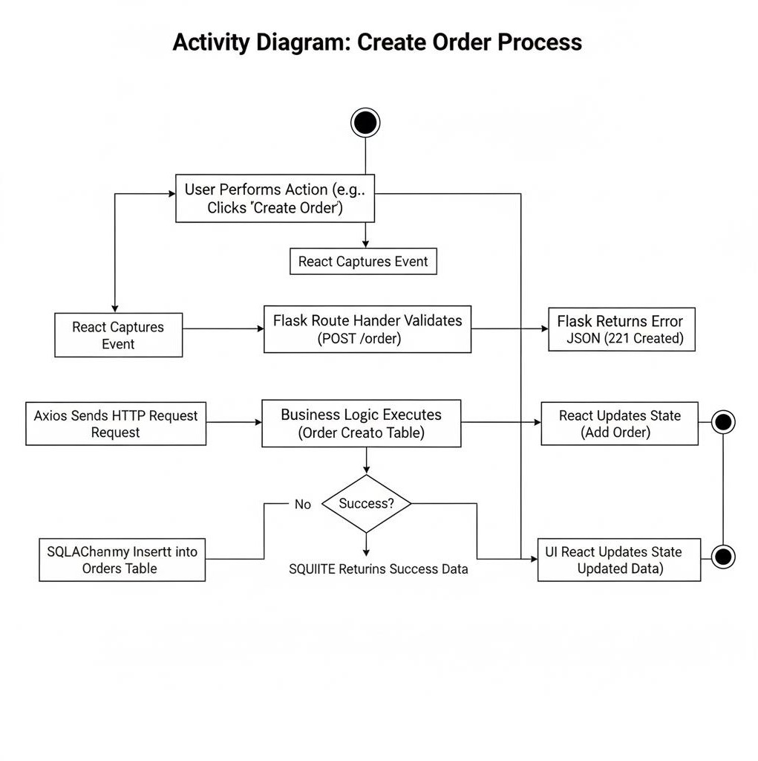

Information Flow
Information flows between components through HTTP communication and JSON data format.

Data Movement:
User → React UI → Axios → Flask Routes → SQLAlchemy → SQLite SQLite → SQLAlchemy → Flask → JSON Response → React UI
The system is stateless, meaning each request is independent and does not rely on previous sessions.


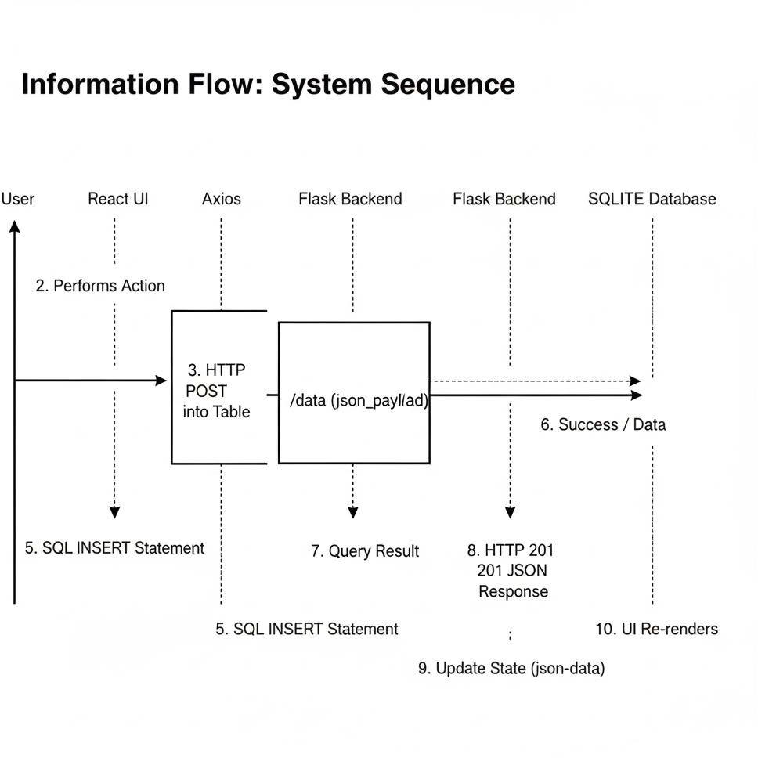

Component Design
The system consists of the following components:

The system consists of the following components:

Frontend Component (React.js)

- Provides a dynamic user interface for managing manufacturing operations such as orders and inventory.
- Sends HTTP API requests to the Flask backend and displays JSON responses dynamically.

Backend Component (Python Flask Application)

- Handles incoming HTTP requests and processes business logic for order and inventory



management.
- Exposes REST APIs using Flask and interacts with the database using SQLAlchemy ORM.

Database Component (SQLite Database)

- Stores manufacturing-related data such as orders, inventory, and product details.
- Lightweight file-based database integrated with Flask via SQLAlchemy ORM.

Containerization Component (Docker)

- Packages the React frontend and Flask backend into container images for consistent deployment.
- Ensures the application runs uniformly across development and production environments.

Orchestration Component (Kubernetes – Minikube)

- Manages Docker containers as Pods and handles scaling using replicas.
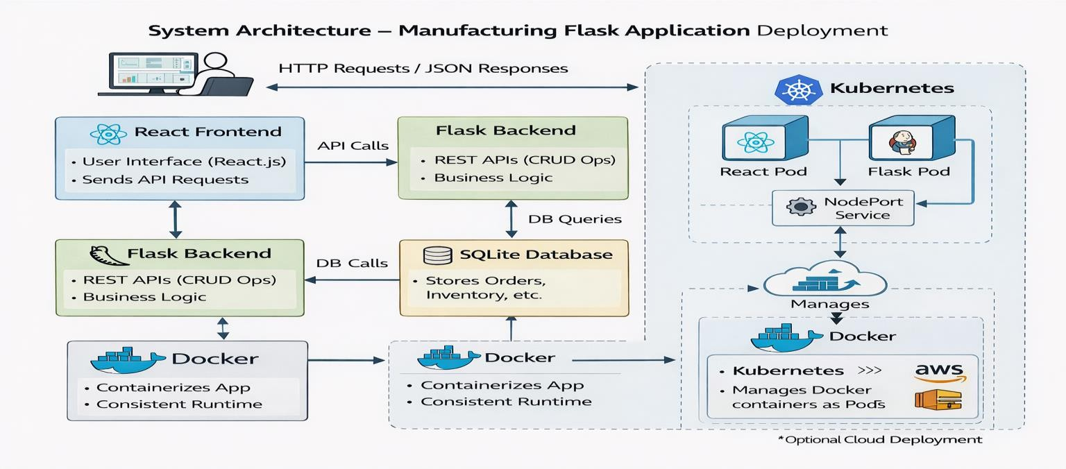
- Provides service exposure and implements rolling updates for zero-downtime deployment.

Key Design Considerations
- Scalability: Kubernetes allows horizontal scaling by increasing pod replicas to handle more users and requests efficiently.
- Performance: REST API architecture ensures fast request-response communication between React frontend and Flask backend.
- Security: Backend input validation, container isolation, and optional HTTPS configuration ensure secure communication and data protection.



  - Reliability: Kubernetes rolling updates
and pod management ensure high availability and zero downtime during deployments.

- Maintainability: Separation of frontend (React) and backend (Flask) enables modular development and easier updates.
- Portability: Docker containerization ensures the application runs consistently across local (Minikube) and cloud environments.

API Catalogue
The Manufacturing Management System uses REST APIs to enable communication between the React frontend and Flask backend. These APIs allow users to manage orders and inventory.

Method | Endpoint | Description
GET | /orders | Retrieve all orders
GET | /orders/{id} | Retrieve a specific order
POST | /orders | Create a new order
PUT | /orders/{id} | Update existing order
DELETE | /orders/{id} | Delete an order
GET | /inventory | Retrieve inventory details
POST | /inventory | Add new inventory item
PUT | /inventory/{id} | Update inventory item
DELETE | /inventory/{id} | Delete inventory item

Data Design
Data Design defines how data is structured, stored, accessed, secured, and maintained within the Manufacturing Order C Inventory Management System.
The system uses a relational database approach implemented using SQLite and managed through the SQLAlchemy ORM framework. The data design ensures integrity, consistency, scalability, and maintainability of information across the system.
The database is normalized to reduce redundancy and improve performance. All business entities such as Orders and Inventory Items are represented as structured tables with defined relationships and constraints.
The data design supports:
- Order lifecycle tracking
- Inventory stock monitoring
- Dashboard summary computation
- CRUD operations via REST APIs


- Future scalability for additional modules

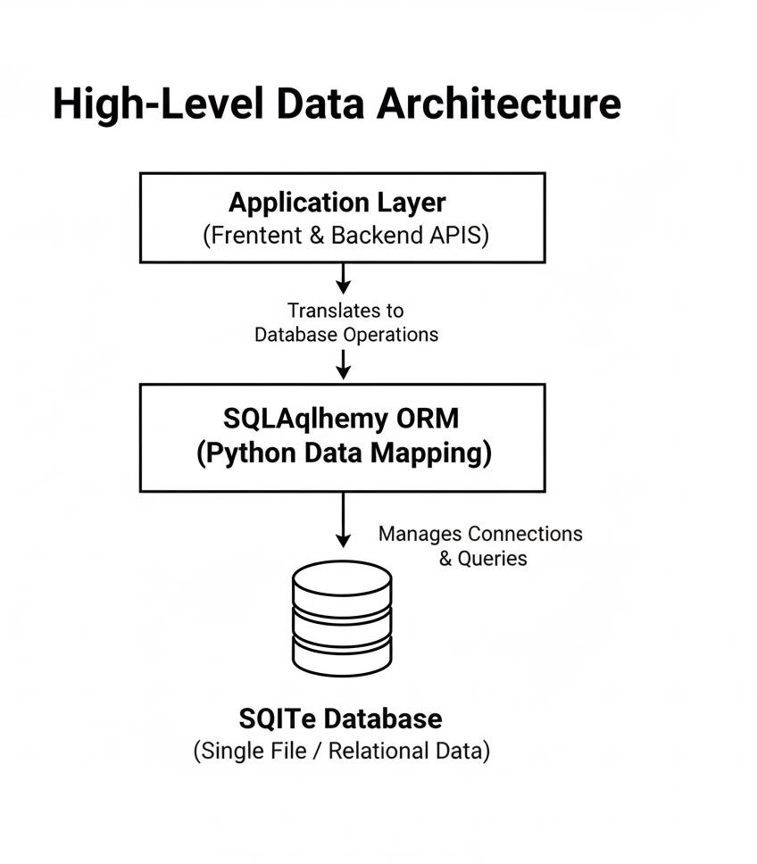

Data Model
The Inventory table stores product stock information such as item ID, item name, stock quantity, minimum threshold, and last updated date.
- The Orders table stores order details such as order ID, product ID, quantity ordered, order status, and created date.
- The Orders table is linked to the Inventory table using a foreign key (product/item ID).
- When a new order is placed, the stock quantity in the Inventory table is updated automatically.
- These tables are connected using primary keys and foreign keys to maintain data consistency and ensure accurate stock management.


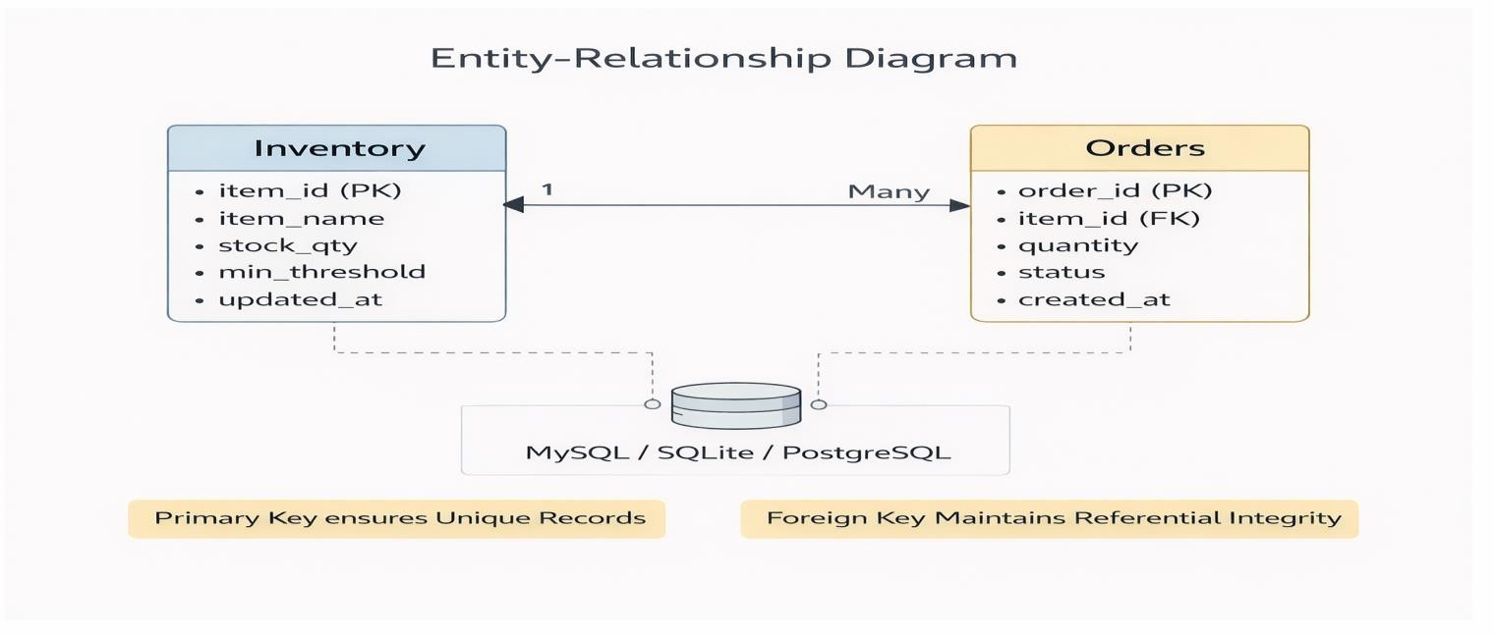

Data Access Mechanism

- The backend uses REST APIs to send and receive data from the database (MySQL / SQLite / PostgreSQL).
- The backend provides secure database access using authentication and validation.
- The backend performs operations such as insert, update, delete, and fetch data for orders and inventory.
- Real-time updates (if implemented) can be handled using WebSocket or periodic API polling to update stock and order status on the frontend.


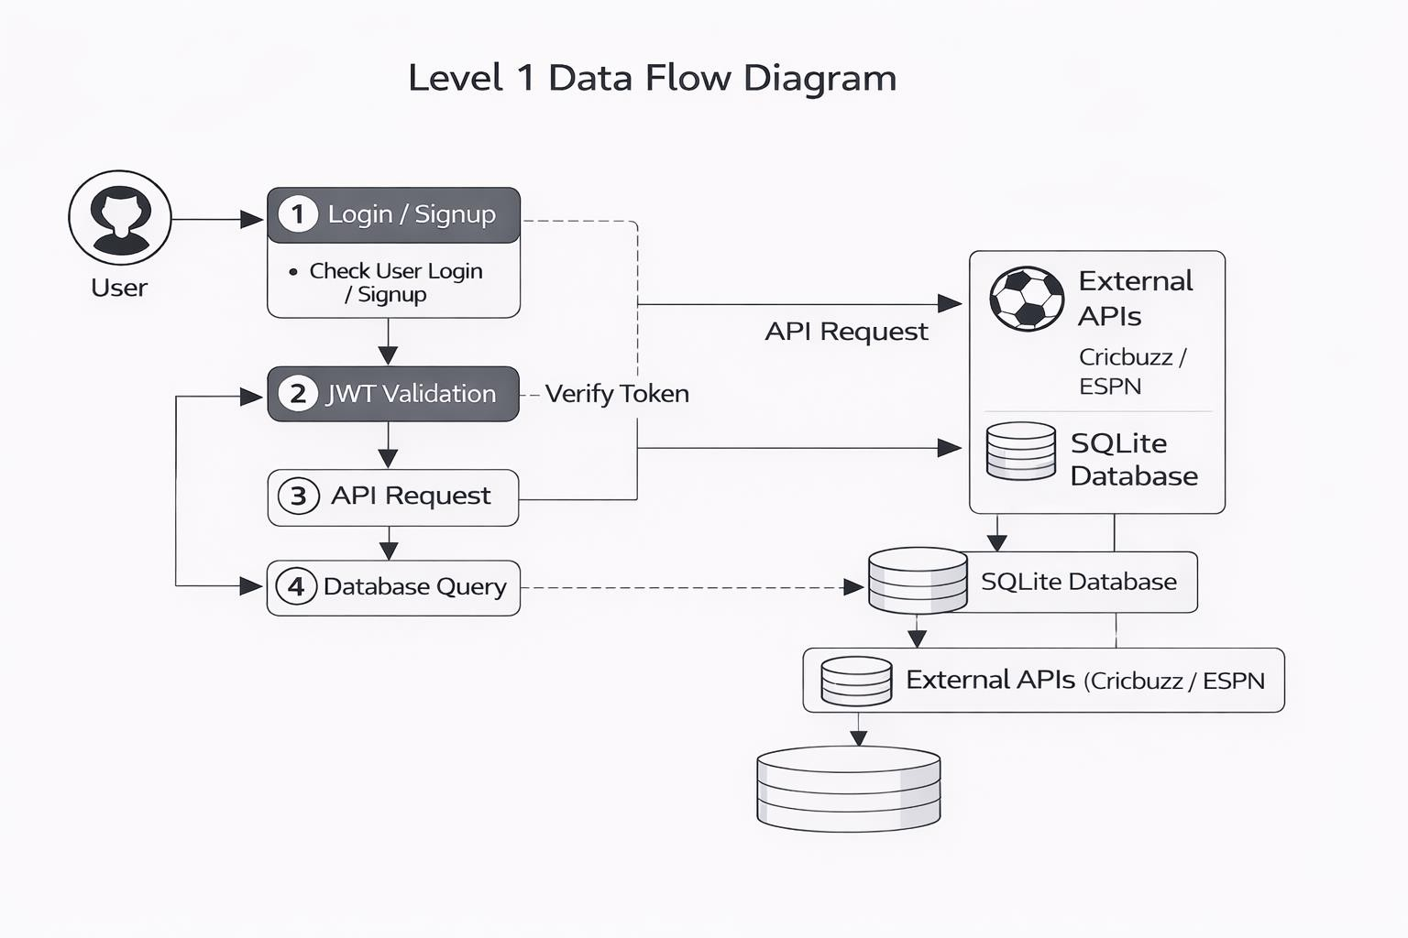

Data Retention Policies
Data retention policies define how long data is stored and managed in the system.
- Order data is stored permanently for record-keeping and tracking purposes.
- Inventory data is stored and updated regularly based on stock changes.
- Old or cancelled orders can be archived if required to improve performance.
- Database backups are maintained regularly to prevent data loss.

Data Migration
- The backend processes order and inventory data from API requests.
- The received data is validated and converted into the required database format.
- The backend stores this data in the relational database (MySQL / SQLite / PostgreSQL).
- Existing inventory records are updated when stock quantity changes.



- New order records are inserted when a
new order is placed.
- Data consistency is maintained using primary and foreign key constraints.
- This process ensures the database always contains accurate and up-to-date stock and order information.

Interfaces
- The User Interface allows users to interact with the system through web browsers.
- The Frontend Interface is developed using React.js and provides screens for managing orders and viewing inventory stock.
- The Backend Interface is developed using Node.js / Express or Flask (depending on your project) and handles API requests from the frontend.
- The API Interface enables communication between frontend and backend using REST APIs.
- The Database Interface allows the backend to access and manage data stored in the relational database.
- The Deployment Interface allows the application to run inside Docker containers and can be hosted on cloud platforms like AWS EC2.

State and Session Management
- User Authentication: The system uses secure authentication to manage user login and access control.
- Session Creation: When a user logs in, a secure session is created for that user.
- JWT Token Generation: After successful login, the system generates a JWT (JSON Web Token) for authentication.
- Token Storage: The frontend securely stores the JWT token (e.g., in local storage or HTTP-only cookies).
- Token Transmission: The frontend sends the token with every API request to verify the user identity.
- Token Verification: The backend verifies the token before granting access to protected routes such as order creation or inventory updates.
- Authorization Control: Only authorized users can create, update, or delete orders



and inventory records.
- Active Session Management: The session remains active while the user is using the application.
- Session Termination: The session ends when the user logs out or when the token expires.

Caching
- Caching is used to improve system performance and reduce database load.
- Frequently accessed data such as inventory stock details are temporarily stored.
- The backend may store recently accessed order and stock data in memory for faster access.
- This reduces repeated database queries for the same data.
- Cached data helps in providing faster responses to user requests.
- Only updated or changed data is refreshed instead of reloading everything.
- Caching reduces server processing time and improves overall system performance.
- Cached data is refreshed regularly to maintain accuracy.

Non-Functional Requirements

Security Aspects
- Authentication System: Secure login system ensures only valid users can access the application.
- JWT Authentication: JWT (JSON Web Token) is used to verify user identity for every request.
- Authorized Access Control: Only authenticated users can access order and inventory management features.
- Secure Data Storage: Sensitive user information is securely stored in the database.
- HTTPS Communication: HTTPS ensures secure data transmission between frontend and backend.



  - Unauthorized Access Prevention: Unauthorized users cannot access protected resources.
- API Security: API endpoints are protected and validated using authentication tokens.
- Database Access Control: Database permissions prevent unauthorized data modification.

Performance Aspects
- Efficient API Design: Optimized REST APIs ensure quick response to user requests.
- Fast Data Retrieval: Database queries are optimized for better performance.
- Caching Mechanism: Frequently accessed inventory and order data is cached to reduce load.
- Docker Deployment: Docker ensures consistent and reliable performance across environments.
- Cloud Scalability (Optional): If deployed on AWS EC2, the system can scale to handle higher traffic.
- System Reliability: The system ensures smooth and continuous operation without downtime.
- Quick Stock Updates: Inventory updates reflect immediately after order placement.

References
- React.js Official Documentation – https://react.dev

- Python Official Documentation – https://docs.python.org/3/

- Flask Official Documentation – https://flask.palletsprojects.com

- Docker Official Documentation – https://docs.docker.com

- Amazon Web Services (AWS) Documentation – https://docs.aws.amazon.com

- SQLite Official Documentation – https://www.sqlite.org/docs.html

(Use this if you are using SQLite)

- MySQL Official Documentation – https://dev.mysql.com/doc

(Use this if you are using MySQL instead of SQLite)

